# Os lab 9 report 20k1691

Implementing the C code given in the link for 50 thre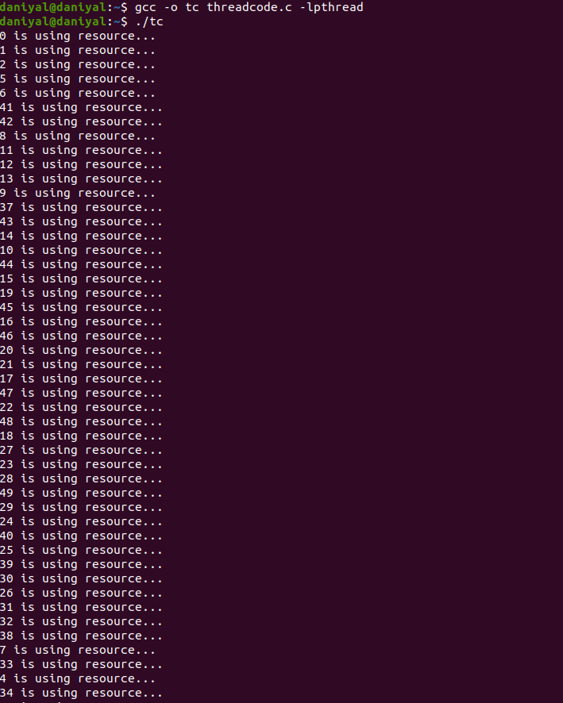

Altered code to implement Semaphores instead of while spin locks

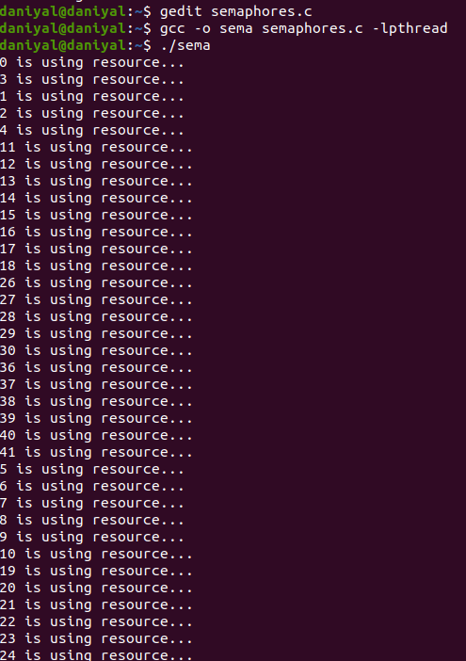

Shell script for 20

